Stonybrook Middle School
About Us
- Our selection of educational goals as well as our assessment and instructional practices are guided by “This We Believe” and Deeper Learning pedagogy
- We are home to 441 students, 26.5 teachers, 9 Educational Assistants, 1 Admin Secretary, 1 Secretary, 1 Library Support Specialist, and 5 custodial staff
- Students are engaged in core academic programs, athletics (intramurals, cross-country, volleyball, basketball, badminton, track and field), music (choir, band), and the arts (visual, drama, and digital)
- Our school has created a culture of kindness through such events as a Week of Kindness, participation in Orange Shirt Day and Character Day
- Student leadership opportunities that hosted special events, created community connections and raised awareness of broader issues.
Contact Us

Principal: Rita Rebizant
rrebizant@hsd.ca
VP: A.J. Neufeld aneufeld@hsd.ca

77 Lumber Ave
Steinbach, Manitoba
R5G 0R3

Phone: (204) 326-6481
Email: sms@hsd.ca

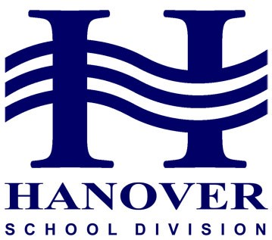
Priority Planning 2019-20
READY TO LEARN
Be Responsible Be Respectful Be Safe
Planning Priority #1
Educators use multiple learning and teaching approaches
Incorporation of strategies where students provoke, explore, and reflect on their learning.
Strategies and Success Indicators
- Increase in student engagement with Visible Learning, Makerspace and cross curricular activities between Industrial Arts/Human Ecology and Academics
- Celebration of Learning showcasing student reflection and engaged learning
- Continued teaching and learning about Coding, Robotics and Responsible Use of Technology skills

Planning Priority #2
Ongoing Professional Development and collaboration that reflects courage and best educational practice
Providing opportunities for staff to engage with Deeper Learning, focusing specifically on Collaboration and Reflection to improve student engagement
Strategies and Success Indicators
- All teachers engaged in Deeper Learning Professional Development that focus on the development of student skills that incorporate collaboration, reflection and creativity
- Students have increased individual and small group literacy and numeracy support based on Strong Connections Data
- Continued building and development of the Celebration of Learning to incorporate the Arts and Music

Planning Priority #3
The health and wellness needs of Middle Years students are supported through curricula, school-wide programs and practices
Strategies and Success Indicators
- Student Care Team work closely together with students, parents and teachers to address social, emotional and behavioural challenges
- Increased physical activity opportunities with additional fitness and outdoor play and extended morning breaks
- Students have opportunities to practice mindfulness in classrooms to improve their own learning
- Students have increased access to guidance and friendship groups to alleviate anxiety
- Students have access to healthy food made available through the breakfast and lunch programs

