Stonybrook Middle School
About Us
- Our selection of educational goals as well as our assessment and instructional practices are guided by the “This We Believe” philosophy and Deeper Learning Pedagogy
- We are home to 441 students, 27 teachers, 9 Educational Assistants, 1 Admin Secretary, 1 Secretary, 1 Library Support Specialist, and 5 custodial staff
- Students are engaged in core academic programs, athletics (intramurals, cross-country, volleyball, basketball, badminton, track and field), music and band, and the arts (visual, drama, and digital), Makerspace, Industrial Arts and Human Ecology programs.
- Our school has created a culture of kindness, focusing on welcoming and engaging new students.
- School-wide events were held by the Student Leadership Team including a SockHop in support of Today House; by the Sports Card Club for the Steinbach Family Resource Centre; and with Peak of the Market for the benefit of South East Helping Hands
Contact Us

Principal: Rita Rebizant
rrebizant@hsd.ca
Vice Principal: A.J. Neufeld aneufeld@hsd.ca

77 Lumber Ave
Steinbach, Manitoba
R5G 0R3

Phone: (204) 326-6481
Email: sms@hsd.ca

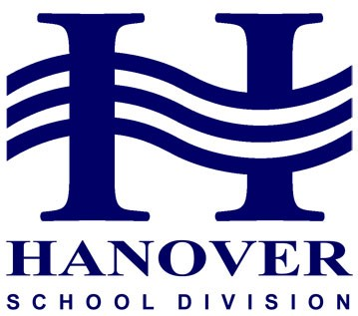
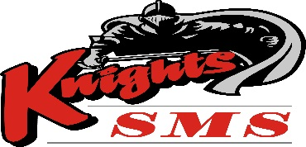
Community Report 2018-19
READY TO LEARN
Be Responsible Be Respectful Be Safe

Planning Priority #1
Educators use multiple learning and teaching approaches
Incorporation of Deeper Learning using inquiry learning that provokes, explores, reflects
Strategies and Success Indicators
              - Makerspace and Hands On Learning Opportunities which included collaborative challenges, creating representations of Social Studies topics and Science experiments
              - Introduction of Robotics Club for Grade 8 students
  - Introduction of Celebration of Learning in lieu of Parent Teacher Interviews
  - Introduction of Celebration of the Arts featuring Drama, Digital Art and Visual Arts
- School Wide Global Day of Design Event during Strong Connections
- Curriculum Based Learning Trips, including the BioLab at St. Boniface Hospital, MTYP, WSO and the International Music Camp
- Opportunities to Leverage Digital in all subject areas

Planning Priority #2
Ongoing PD and collaboration reflects courage & best educational practices.
Professional Development for staff with a focus on developing strong reflection skills that enabled students to have rich learning experiences.
Strategies and Success Indicators
- Literacy and Numeracy Specialists collaborate with classroom teachers to develop common strategies and assessment strategies founded on best practice
- School Based Deeper Learning in-services with Divisional Learning Coach that focused on developing reflection skills for teachers and students
Planning Priority #3
The health & wellness needs of Middle Years students are supported through curricula, school-wide programs and practices
Strategies and Success Indicators
- Ready to Learn is the primary prevention system used to provide positive behavior support for all students
- Students have access to Learning Support, Guidance and Social Worker
- School Lunch and Breakfast program
- Active health opportunities with intramurals, workout clubs and extra PE
- Workout Clubs during lunch recess for boys and girls
- Orange Shirt Day
- Peak of the Market Fundraiser - vegetables donated to Southeast Helping Hands and Soups On
- Week of Kindness

