Stonybrook Middle School
About Us
- Our selection of educational goals as well as our assessment and instructional practices are guided by the “This We Believe” and Deeper Learning philosophy
- We are home to 423 students, 24.5 teachers, 9 Educational Assistants, 1 Admin Secretary, 1 Secretary, 1 Library Support Specialist, and 5 custodial staff
- Students are engaged in core academic programs, athletics (intramurals, cross-country, volleyball, basketball, badminton, track and field), music (choir, band), and the arts (visual, drama, and digital)
- Our school has created a culture of kindness. Last year’s Week of Kindness featured a special guest, Michelle Sawatzky-Koop
- School-wide events were held by the student leaders to raise money for Beautiful Education; by the Sports Card Club for the Steinbach Family Resource Centre; and with Peak of the Market for the benefit of South East Helping Hands
Contact Us

Principal: Rita Rebizant
rrebizant@hsd.ca
VP: A.J. Neufeuld aneufeld@hsd.ca

77 Lumber Ave
Steinbach, Manitoba
R5G 0R3

Phone: (204) 326-6481
Email: sms@hsd.ca

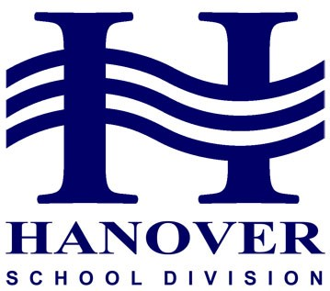
Priority Planning 2018-19
READY TO LEARN
Be Responsible Be Respectful Be Safe
Planning Priority #1

Educators use multiple learning and teaching approaches
Incorporation of strategies where students provoke, explore, and reflect on their learning.

Strategies and Success Indicators
- Increase in student engagement with Visible Learning, Makerspace and cross curricular activities between Industrial Arts/Human Ecology and Academics
- Full year development of skills and opportunities to showcase their learning for grade 8 students in Arts and Music
- Celebration of Learning showcasing student reflection

Planning Priority #2

Ongoing Professional Development and collaboration that reflects courage and best educational practice
Providing opportunities for staff to engage with Deeper Learning, focusing specifically on Collaboration and Reflection to improve student engagement

Strategies and Success Indicators
- All teachers engaged in Deeper Learning Professional Development that focus on the development of student skills that incorporate collaboration and Reflection
- Students have increased individual literacy and numeracy support based on Strong Connections Data

Planning Priority #3

The health and wellness needs of Middle Years students are supported through curricula, school-wide programs and practices

Strategies and Success Indicators
- Student Care Team work closely together with students, parents and teachers to address social, emotional and behavioural challenges
- Increased physical activity opportunities with additional fitness and outdoor play
- Students have opportunities to practice mindfulness in classrooms to improve their own learning
- Students have increased access to guidance and friendship groups to alleviate anxiety
- Students have access to healthy food made available through the breakfast and lunch programs

